

Flight Price Prediction

Submitted By

HariHara Sudhan

**ACKNOWLEDGMENT**

I express my sincere gratitude to Flip Robo Technologies for giving me the opportunity to work on this project on Flight Price Prediction using machine learning algorithms. I acknowledge my indebtedness to the authors of the paper titled: “Airline ticket price and demand prediction: A survey” and the online article titled: “Trying to Predict Airfares When The Unpredictable Happens” for providing me with invaluable insights and knowledge of the various factors that determine the price of Flight tickets.

INTRODUCTION

**Business Problem Framing**

Anyone who has booked a flight ticket knows how unexpectedly the prices vary. The cheapest available ticket on a given flight gets more and less expensive over time. This usually happens as an attempt to maximize revenue based on – • Time of purchase patterns (making sure last-minute purchases are expensive) • 2. Keeping the flight as full as they want it (raising prices on a flight which is filling up in order to reduce sales and hold back inventory for those expensive last-minute expensive purchases) Therefore, a predictive model to accurately predict Air fares is required to be made.

**Conceptual Background of the Domain Problem**

Predictive modelling, Regression algorithms are some of the machine learning techniques used for predicting Flight Ticket prices. Identifying various relevant attributes like Airline Brand, flight duration, source and destination etc are crucial for working on the project as they determine the valuation of air fare.

**Review of Literature**

A Research paper titled: “Airline ticket price and demand prediction: A survey” by Juhar Ahmed Abdella and online article titled: “Trying to Predict Airfares When The Unpredictable Happens” were reviewed and studied to gain insights into all the attributes that contribute to the pricing of flight tickets. It is learnt that deterministic features like Airline Brand, flight number, departure dates, number of intermediate stops, week day of departure, number of competitors on route and aggregate features – which are based on collected historical data on minimum price, mean price, number of quotes on non-stop,1-stop and multi-stoppage flights are some the most important factors that determine the pricing of Flight Tickets.

**Motivation for the Problem Undertaken**

With airfares fluctuating frequently, knowing when to buy and when to wait for a better deal to come along is tricky. The fluctuation in prices is frequent and one has limited time to book the cheapest ticket as the prices keep varying due to constant manipulation by Airline companies. Therefore, it is necessary to work on a predictive model based on deterministic and aggregate feature data that would predict with good accuracy the most optimal Air fare for a particular destination, route and schedule.

**Analytical Problem Framing**

**Mathematical/ Analytical Modeling of the Problem**

Various Regression analysis techniques were used to build predictive models to understand the relationships that exist between Flight ticket price and Deterministic and Aggregate features of Air travel. The Regression analysis models were used to predict the Flight ticket price value for changes in Air travel deterministic and aggregate attributes. Regression modelling techniques were used in this Problem since Air Ticket Price data distribution is continuous in nature. In order to forecast Flight Ticket price, predictive models such as ridge regression Model, Random Forest Regression model, Decision tree Regression Model, Support Vector Machine Regression model and Extreme Gradient Boost Regression model were used to describe how the values of Flight Ticket Price depended on the independent variables of various Air Fare attributes.

**Data Sources and their formats**

The Dataset was compiled by scraping Data for various Air Fare attributes and Price from https://www.yatra.com/ and <https://www.easemytrip.com/>

The data was converted into a Pandas Dataframe under various Feature and Label columns and saved as a .csv file.

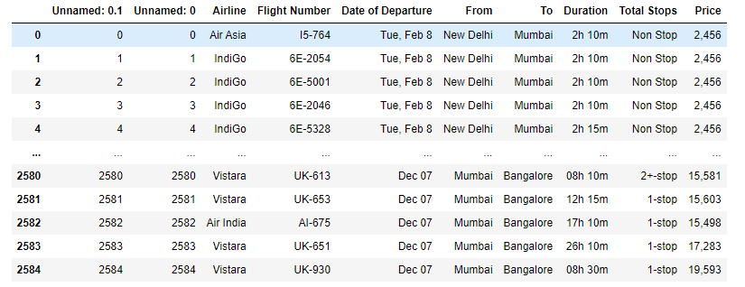

Dataset Description

The Independent Feature columns are:

• Airline: The name of the airline.

• Flight Number: Number of Flight

• Date of Departure: The date of the journey

• From: The source from which the service begins

• To: The destination where the service ends

• Duration: Total duration of the flight

• Total Stops: Total stops between the source and destination. Target / Label Column:

• Price: The Price of the Ticket

**Data Preprocessing Done**

• Duplicate data elements in various columns: ‘Airline’,’From’,’To’, which had their starting letters in upper case and lower case were converted to data elements starting with uppercase letters.

• Data in column ‘Price’ was converted to int64 data type.

• Columns: Unnamed: 0(just a series of numbers) was dropped since it doesn't contribute to building a good model for predicting the target variable values.

• The Date format of certain data elements in ‘Date of Departure’ was changed to match the general Date format of majority of the data elements of the column.

**Feature Engineering:**

• In order to better understand the relationships between Flight price and Air Fare attributes, ‘Day’,’Date’ and ‘Month’ columns were created based on data of existing column: ‘Date of Departure’.

• The values in Column: ‘Duration’ were converted from HoursMinutes format to minute format and the data type was converted to int64.

Data Inputs- Logic- Output Relationships

• The Datasets consist mainly of Int and Object data type variables. The relationships between the independent variables and dependent variable were analysed.

**Hardware and Software Requirements and Tools Used**

**Hardware Used:**

• Processor: AMD Ryzen 9 5900HX(8 Cores 16 Logical Processors) • Physical Memory: 16.0GB (3200MHz)

• GPU: Nvidia RTX 3060 (192 bits), 6GB DDR6 VRAM, 3840 CUDA cores.

Software Used:

• Windows 10 Operating System

• Anaconda Package and Environment Manager: Anaconda is a distribution of the Python and R programming languages for scientific computing, that aims to simplify package management and deployment. The distribution includes data-science packages suitable for Windows and provides a host of tools and environment for conducting Data Analytical and Scientific works. Anaconda provides all the necessary Python packages and libraries for Machine learning projects.

• Jupyter Notebook: The Jupyter Notebook is an open-source web application that allows data scientists to create and share documents that integrate live code, equations, computational output, visualizations, and other multimedia resources, along with explanatory text in a single document.

• Python3: It is open source, interpreted, high level language and provides great approach for object-oriented programming. It is one of the best languages used for Data Analytics And Data science projects/application. Python provides numerous libraries to deal with mathematics, statistics and scientific function.

• Python Libraries used:

o Pandas: For carrying out Data Analysis, Data Manipulation, Data Cleaning etc

o Numpy: For performing a variety of operations on the datasets.

o matplotlib.pyplot, Seaborn: For visualizing Data and various relationships between Feature and Label Columns

o Scipy: For performing operations on the datasets

o Statsmodels: For performing statistical analysis

• sklearn for Modelling Machine learning algorithms, Data Encoding, Evaluation metrics, Data Transformation,Data Scaling, Component analysis,Feature selection etc.

Exploratory Data Analysis

Visualizations

Barplots,Distplots,Boxplots,Countplots,lineplots were used to visualise the data of all the columns and their relationships with Target variable.

Univariate Analysis

Analyzing the Target Variable

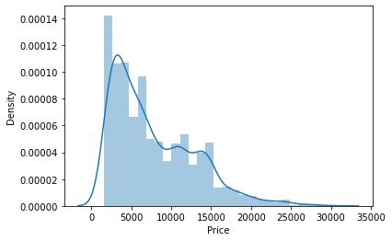

From the graph above it is observed that the Price data forms a continuous distribution with mean of 7748.33 and tails of from 15000 mark and the distribution is skewed.

Analyzing the Feature Column

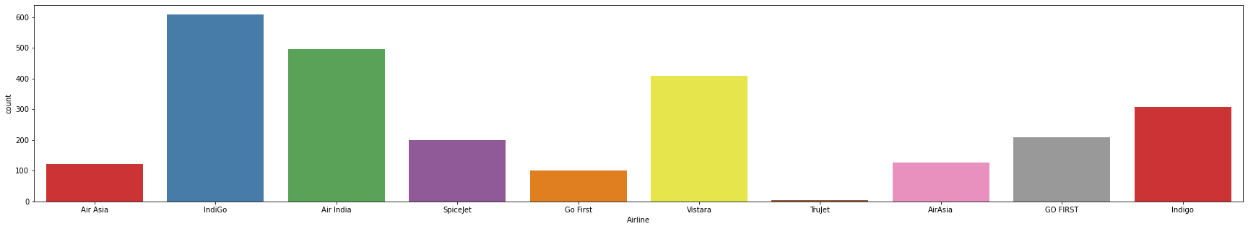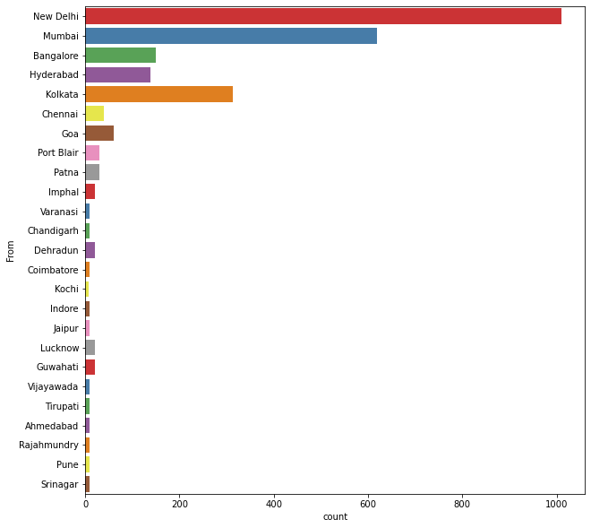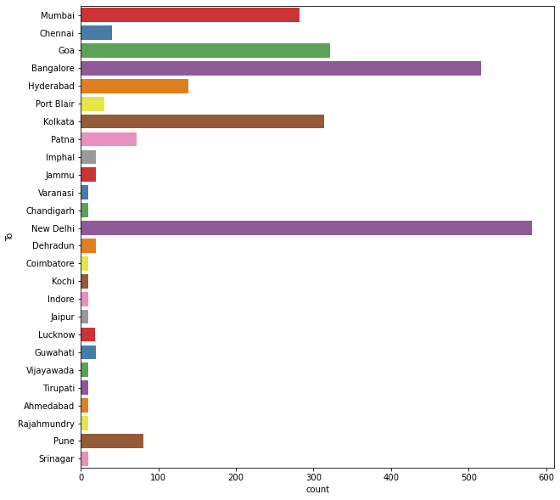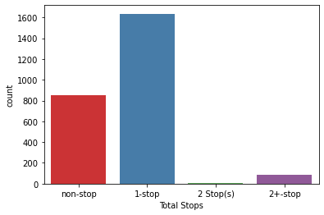

Following observations are made from graphs above:

• IndiGo has the highest number of flights followed by Air India and Vistara

• Highest number of flights are from Delhi followed by Mumbai, Kolkata,Bangalore and Hyderabad

• New Delhi is the most popular destination followed by Bangalore, Goa, Kolkata and Mumbai

• Highest number of flights have only 1 stop between source and destination while 2nd highest number of flights are non stop

**Bivariate Analysis**

Interpreting Relationship between Dependent Variable and Independent Variable Columns

Analyzing Relationship between Day, Month columns and Price

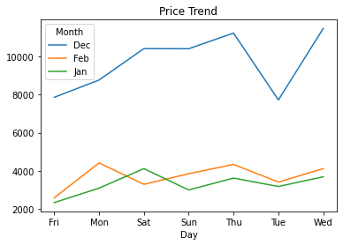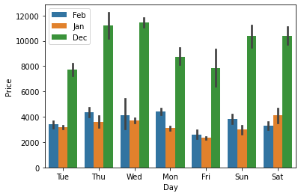

Following observations are made from graphs above:

• On an average, there is a steady decline in Flight price from December to February, with the prices being lowest in January.

• Flight Prices increase on an average, as the day of departure gets nearer.

• Flight Ticket prices are the highest on Thursdays,Mondays and during the weekend on an average.

Analyzing Relationship between Airlines, Flight Duration and Price.

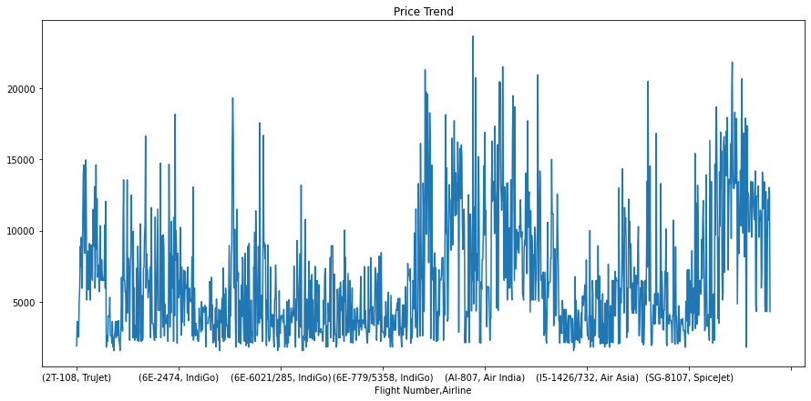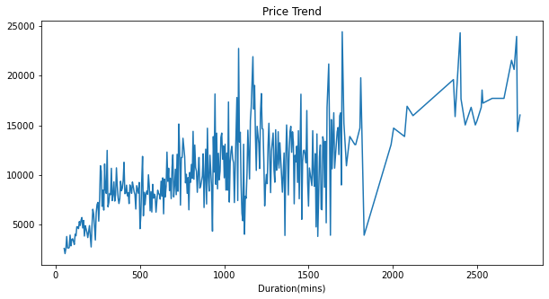

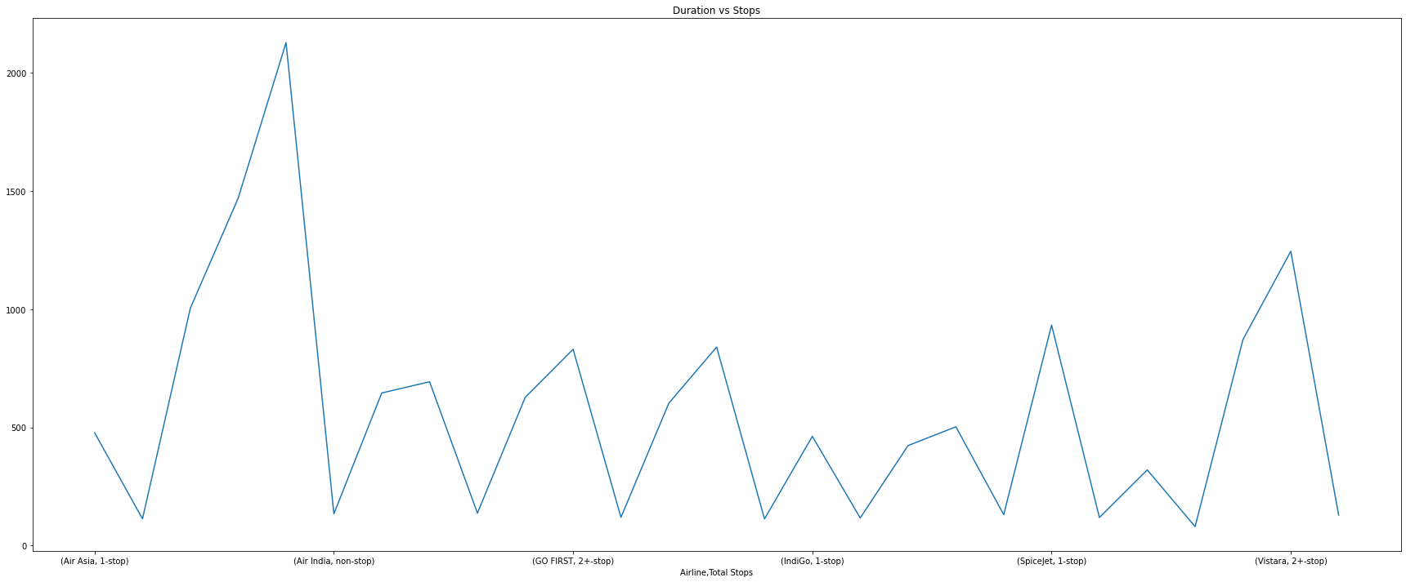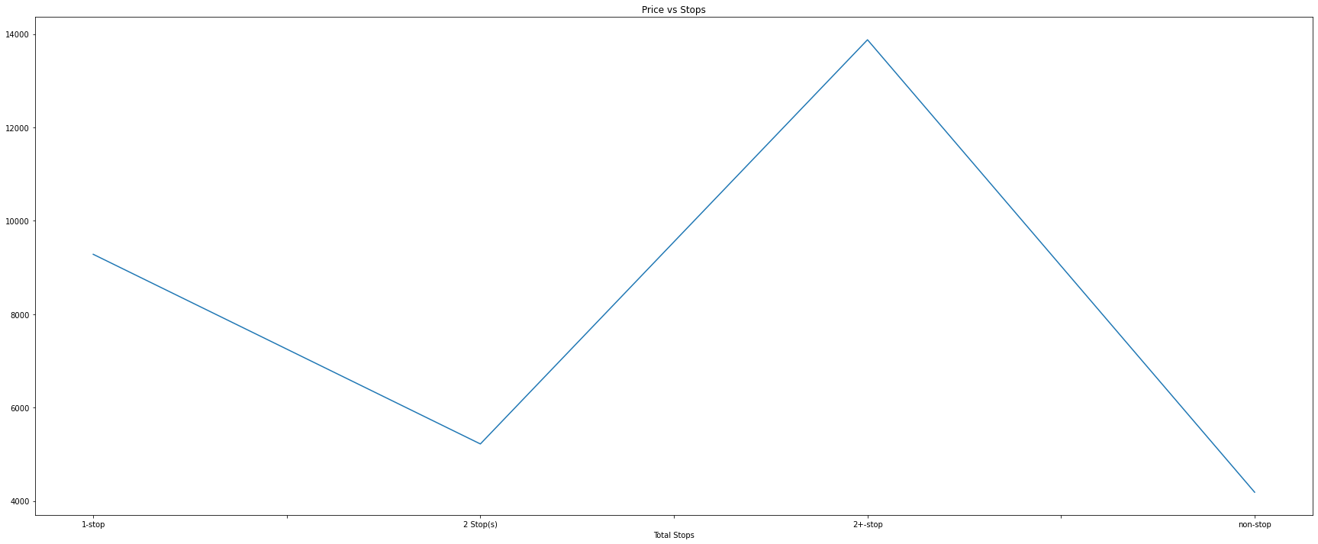

Following Observation is made from graphs above:

o Trujet, IndiGo,SpiceJet and Air Asia offer air tickets at the most affordable prices on average, whereas Vistara, Air India are the most expensive on average.

o It can be observed that Number of Stops impact the travel time of Airlines.

o It can be observed that Number of Stops impact the Air Ticket Pricing of Airlines.

o There is a linear relationship between Price and flight duration.

**MULTIVARIATE ANALYSIS**

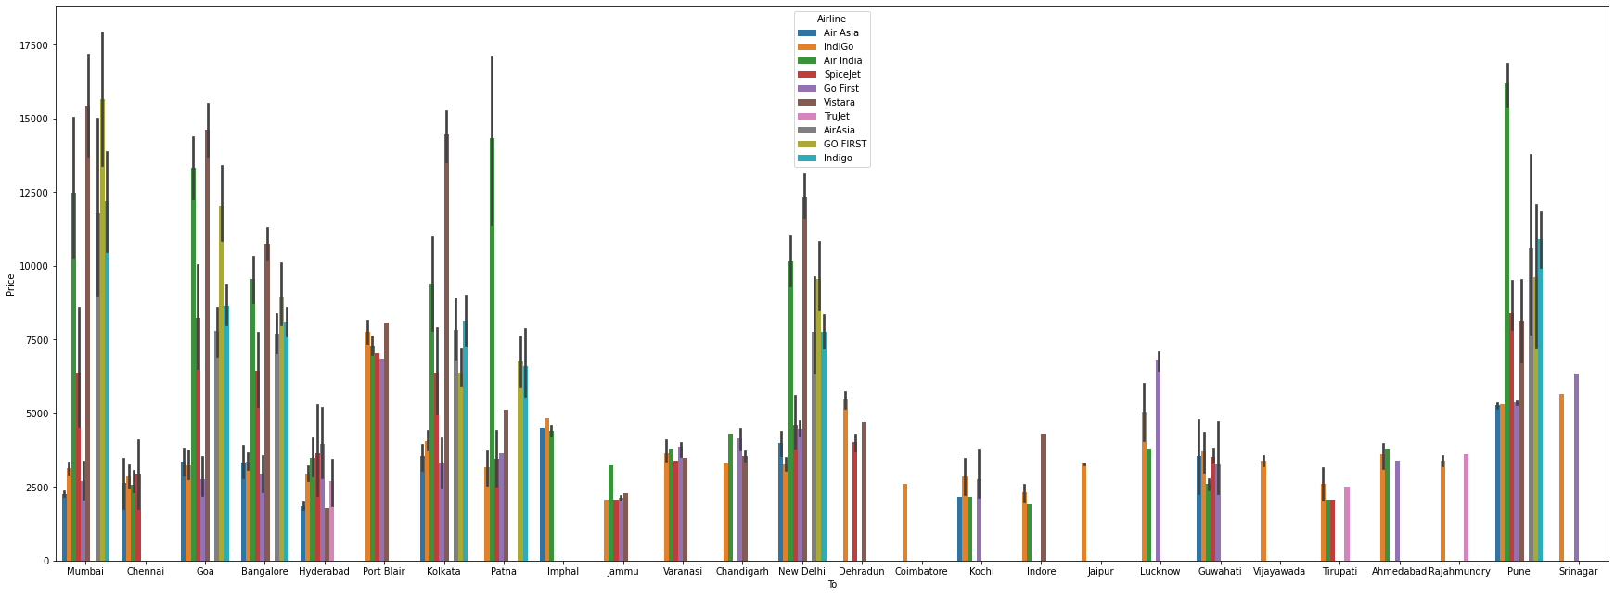

Following Observations are made from graphs above:

• There is a linear relationship between Price and flight duration.

• Indigo,Air Asia and Spicejet provide most affordable Airtickets to the destinations.

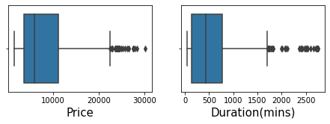

**Finding Correlation between Feature and Target column**

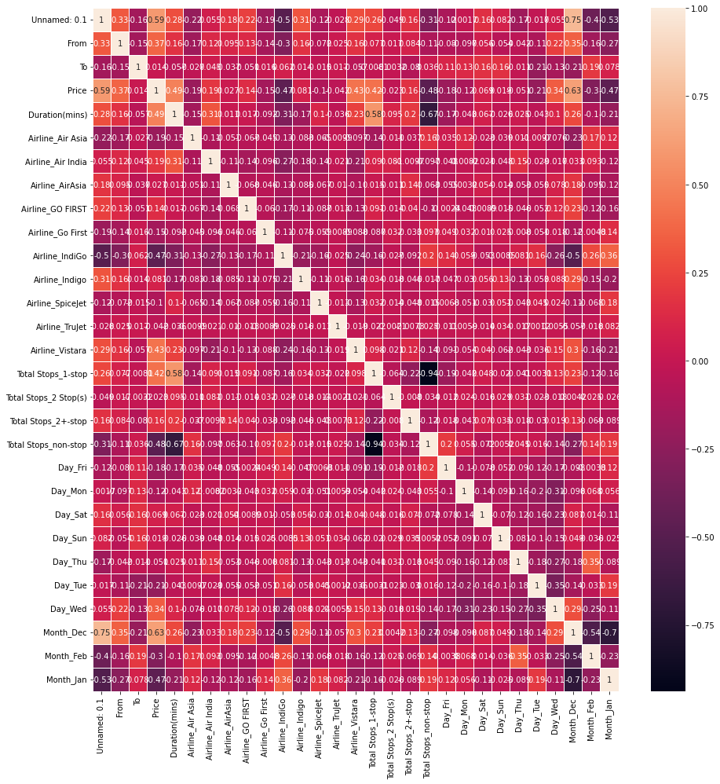

It is observed that Month_Dec, Duration(mins), Airline_Vistara,Total Stops_1-stop and From have the highest positive correlation with Price, while Date,Total Stops_non-stop,Month_Jan,Airline_IndiGo have the highest negative correlation with Price.

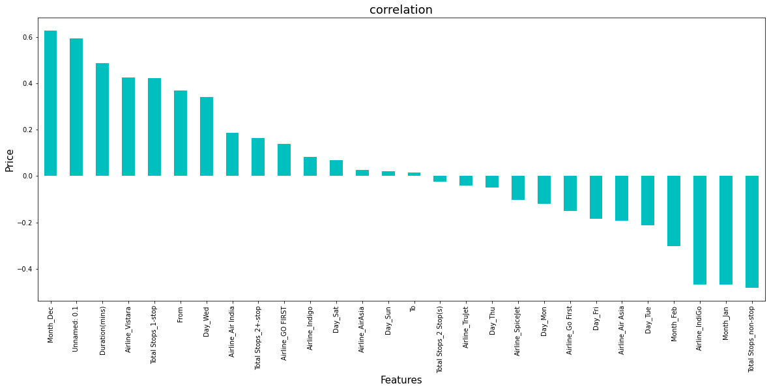

**The model algorithms used were as follows:**

• DecisionTreeRegressor: Decision Tree solves the problem of machine learning by transforming the data into a tree representation. Each internal node of the tree representation denotes an attribute and each leaf node denotes a class label. A decision tree does not require normalization of data. A decision tree does not require normalization of data.

• RandomForestRegressor: A random forest is a meta estimator that fits a number of classifying decision trees on various sub-samples of the dataset and uses averaging to improve the predictive accuracy and control over-fitting. A random forest produces good predictions that can be understood easily. It reduces overfitting and can handle large datasets efficiently. The random forest algorithm provides a higher level of accuracy in predicting outcomes over the decision tree algorithm.

• GradientBoost regression is a model tuning method that is used to analyse any data that suffers from multicollinearity. It also produces good predictions that can be understood easily. It reduces overfitting and can handle large datasets efficiently.

•Linear Regression Since the features have multicollinearity occurs, least-squares are unbiased, and variances are large, this results in predicted values to be far away from the actual values. Ridge shrinks the parameters. Therefore, it is used to prevent multicollinearity.

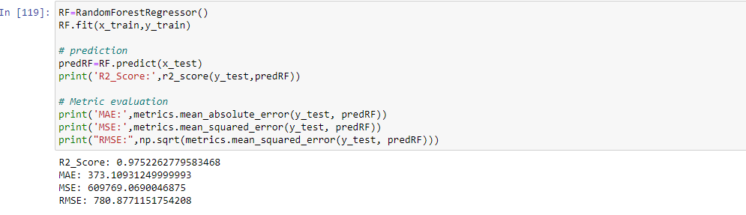

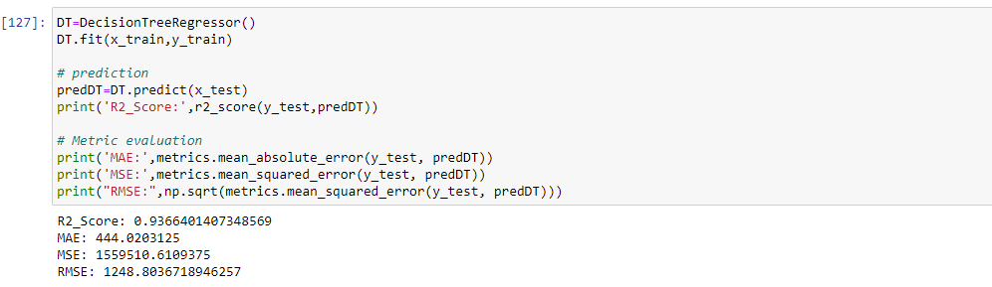

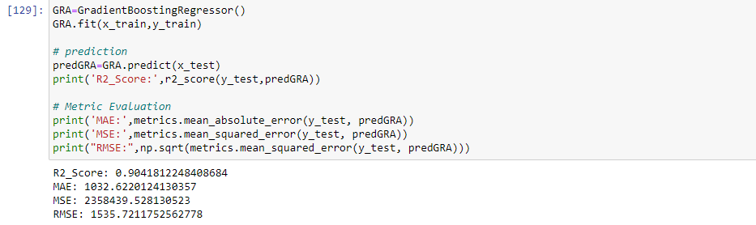

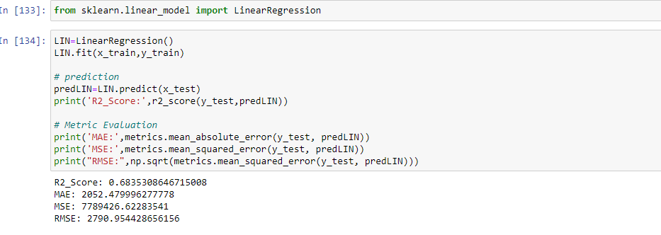

Best random state was determined to be 66.

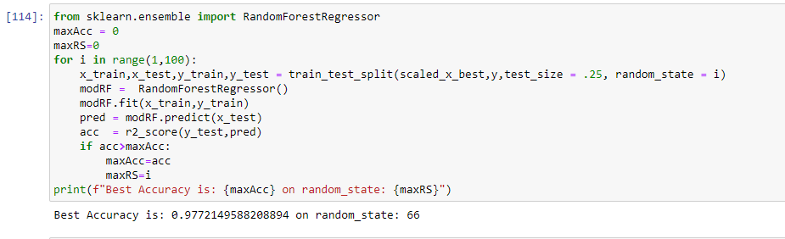

**Interpretation of the Results**

Based on comparing Accuracy Score results with Cross Validation results, it is determined that Random Forest Regressor is the best model. It also has the lowest Root Mean Squared Error score.

**Hyper Parameter Tuning**

GridSearchCV was used for Hyper Parameter Tuning of the Random Forest Regressor model.

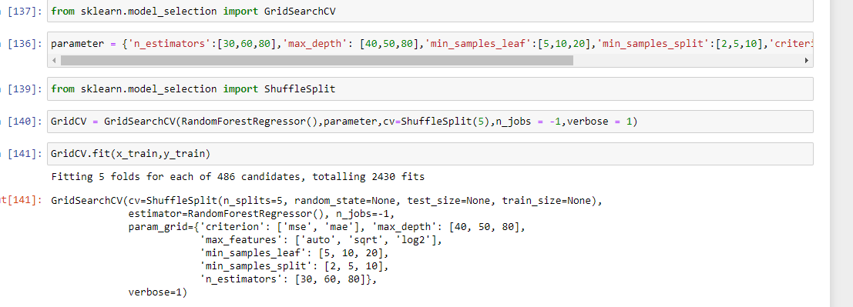

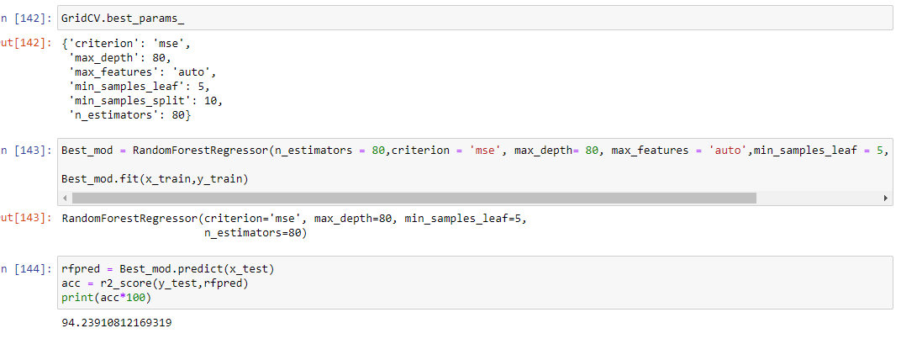

In summary, Based on the visualizations of the feature-column relations hips, it is determined that, Features like Source,month,Duration,Total St ops,Airline,Date are some of the most important features to predict the la bel values. Random Forest Regressor Performed the best out of all the models that were tested. It also worked well with the outlier handling.

**CONCLUSION**

Key Findings and Conclusions of the Study and Learning Outcomes with respect to Data Science

Based on the in-depth analysis of the Flight Price Prediction Project, The Exploratory analysis of the datasets, and the analysis of the Outputs of the models the following observations are made:

• Air Fare attributes like Date,Month,Duration,Total Stops etc play a big role in influencing the used Flight price.

• Airline Brand also has a very important role in determining the used Flight Ticket price.

• Various plots like Barplots,Countplots and Lineplots helped in visualising the Feature-label relationships which corroborated the importance of Air Fare features and attributes for estimating Flight Ticket Prices.

• Due to the Training dataset being very small, only very small amount of the outliers was removed to ensure proper training of the models.

• Therefore, Random Forest Regressor, which uses averaging to improve the predictive accuracy and controls over-fitting. performed well despite having to work on small dataset and produced good predictions that can be understood easily.

**Learning Outcomes of the Study in respect of Data Science**

Data cleaning was a very important step in removing plenty of anomalous data from the huge dataset that was provided. Visualising data helped identify outliers and the relationships between target and feature columns as well as analysing the strength of correlation that exists between them.

Limitations of this work and Scope for Future Work A small dataset to work with posed a challenge in building highly accurate models. This project also relied heavily on historical data and was unable to account for various other factors that influence demand and ticket pricing like pandemic status affecting demand, government regulations on air travel, shifting in routes, weather conditions, etc.

Most airline companies also do no publicly make available their ticket pricing strategies, which makes gathering price and air fare related data sets using web scraping the only means to build a dataset for building predicting models.

Availability of more features and a larger dataset would help build better models